**IMPACT COLLEGE OF ENGINEERING & APPLIED SCIENCES**



**DEPARTMENT OF COMPUTER SCIENCE & ENGINEERING**

**TECHNICAL WRITING USING LATEX (BCSL456D)**



**Prepared By,**

**SHWETHA T J**

**Assistant Professor,**

**Department of CS & E**

**ICEAS, BANGALORE**

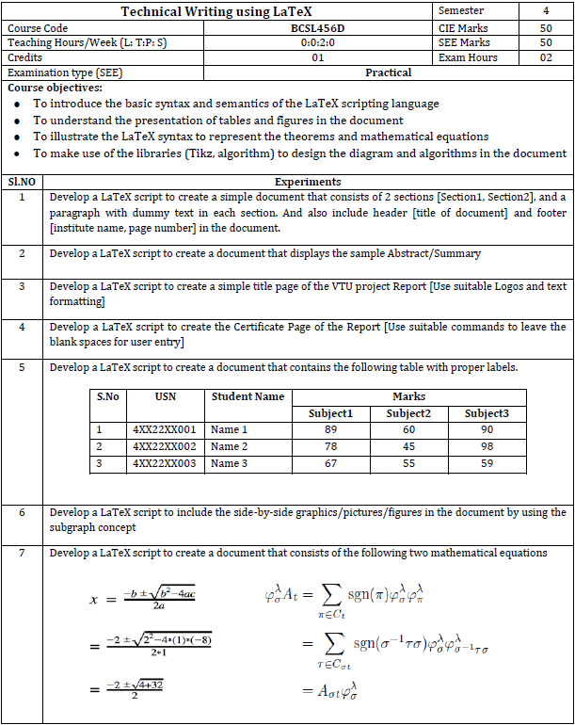

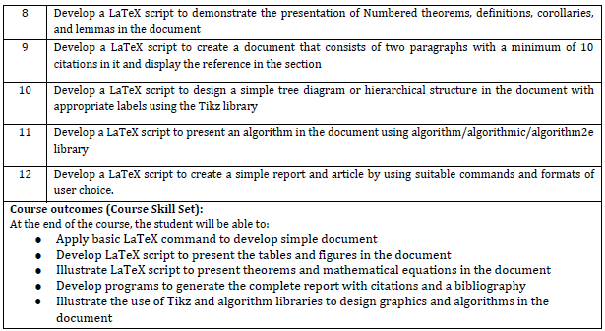

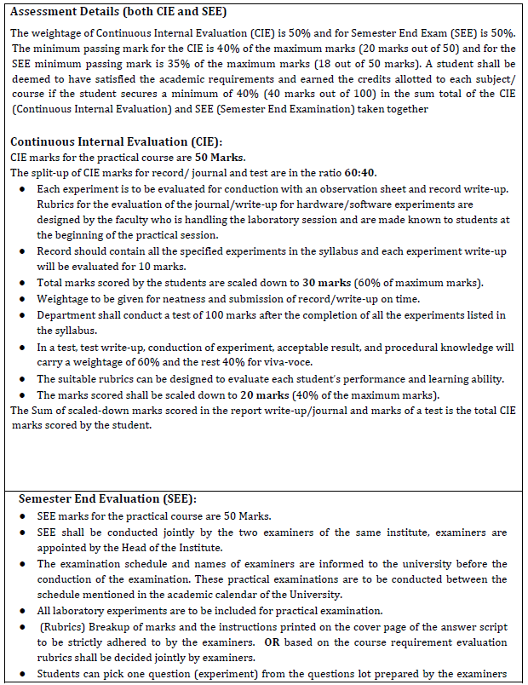

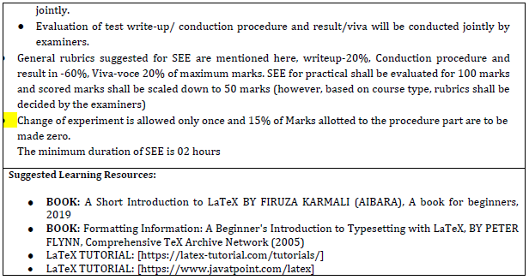

To install Miktex in windows 10

<https://miktex.org/howto/install-miktex>

<https://miktex.org/download>

To install Texmaker

<https://www.xm1math.net/texmaker/download.html>

**1. Develop a LaTeX script to create a simple document that consists of 2 sections [Section1, Section2], and a paragraph with dummy text in each section. And also include header [title of document] and footer [institute name, page number] in the document.**

\documentclass{article}

\usepackage{fancyhdr}

\usepackage{lipsum}

\pagestyle{fancy}

\fancyhf{}

\chead{Document on Dummy Text}

\cfoot{ICEAS \hspace{10.5cm} \thepage}

\begin{document}

\section{Section 1}

\lipsum[1]

\section{Section 2}

\lipsum[2]

\end{document}

**OUTPUT -**

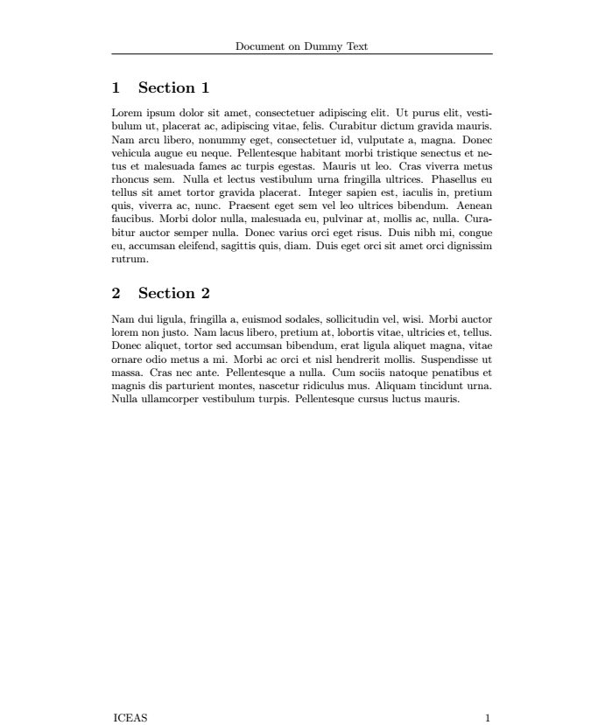

**EXPLANATION –**

When you compile this LaTeX script, it will produce a PDF document with two sections, each containing a paragraph of dummy text. The header will display "Document on Dummy Text", and the footer will display "ICEAS" followed by the page number on each page.

* \documentclass{article}: This line specifies the document class as article, which is suitable for short documents such as articles, reports, and papers.
* \usepackage{fancyhdr}: This line imports the fancyhdr package, which allows for customization of headers and footers in the document.
* \usepackage{lipsum}: This line imports the lipsum package, which provides commands to generate dummy text. It's useful for testing layouts and formatting without having to write actual content. Lorem Ipsum is simply dummy text of the printing and typesetting industry. Lorem Ipsum has been the industry's standard dummy text ever since the 1500s.
* \pagestyle{fancy}: This line sets the page style to fancy, which enables the customization of headers and footers using the fancyhdr package. If we don’t include this, header and footer will not be visible.
* \fancyhf is a merge of \fancyhead and \fancyfoot, hence the name. If you omit the H and the F, it will set the fields for both.
* \chead{Document on Dummy Text}: This line sets the center part of the header to display "Document on Dummy Text".
* \cfoot{ICEAS \hspace{0.5cm} \thepage}: This line sets the center part of the footer to display "ICEAS" followed by some horizontal space (\hspace{0.5cm}) and the page number (\thepage). This will center-align the footer content and place the page number at the center of the footer.
* \begin{document}: This marks the beginning of the document content.
* \section{Section 1}: This command starts a new section titled "Section 1".
* \lipsum[1]: This command generates a paragraph of dummy text. The [1] specifies the number of the Lorem Ipsum paragraph to use.
* \section{Section 2}: This command starts a new section titled "Section 2".
* \lipsum[2]: This command generates another paragraph of dummy text using a different Lorem Ipsum paragraph (number 2 in this case).
* \end{document}: This marks the end of the document content.

**2. Develop a LaTeX script to create a document that displays the sample Abstract/Summary.**

\documentclass[12pt]{article}

\usepackage{lipsum}

\begin{document}

\begin{abstract}

\lipsum[1]

\end{abstract}

\end{document}

**OUTPUT -**

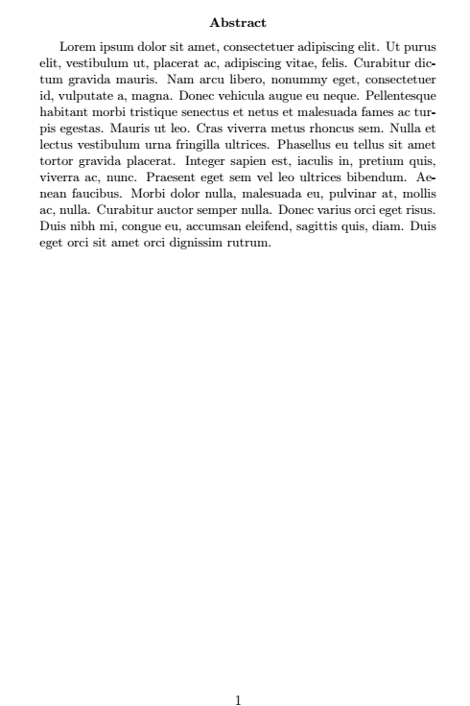

**EXPLANATION –**

* \documentclass{article}: This line specifies the document class as article. The article class is commonly used for short documents such as articles, reports, and papers.
* \usepackage{lipsum}: This line imports the lipsum package, which provides commands to generate dummy text. In this case, it's used to generate dummy text for the abstract.
* \begin{document}: This marks the beginning of the document content.
* \begin{abstract}: This command starts the abstract environment. In LaTeX, the abstract environment is a special environment used to typeset an abstract for a document.
* \lipsum[1]: This command generates a paragraph of dummy text using the lipsum package. The [1] specifies the number of the Lorem Ipsum paragraph to use. lipsum[1] generates the first paragraph of Lorem Ipsum text.
* \end{abstract}: This command ends the abstract environment.
* \end{document}: This marks the end of the document content.

**PROGRAM 2 WITHOUT USING DUMMY TEXT**

**2. Develop a LaTeX script to create a document that displays the sample Abstract/Summary.**

\documentclass[10pt,a4paper]{article}

\usepackage{ragged2e}

\usepackage[left=3cm,right=3cm,top=2cm,bottom=2cm]{geometry}

\begin{document}

\begin{center}

\LARGE\textbf{Abstract}

\end{center}

News has become an important medium for everyone to stay aware and updated with the latest happenings in the world. It is important to note that in recent times with the rise in social media the amount of fake news has surged to dangerous levels. Fake news causes a lot of economic and social problems. It also gets difficult to trace back the source of fake news and hold someone accountable in order to curb it down. It is important to have a mechanism which evicts out fake news and contains only authentic news. With digitization, there has been a drastic increase in the usage of some of the popular social media sites such as Twitter, Facebook, Yahoo, YouTube as a medium of spreading news. There is very little check on the spreading of fake news. Accountability, in terms of how authentic the news is, is very less. Our project aims to create a platform that runs on a blockchain network. News based media will be shared across this network. The origin of data and every user interaction will be recorded and get updated in the decentralized ledger and since it is in the blockchain,

\justify{\textbf{Keywords:} Fake news, Blockchain network, Accountability, Decentralized ledger}

\end{document}

**OUTPUT –**

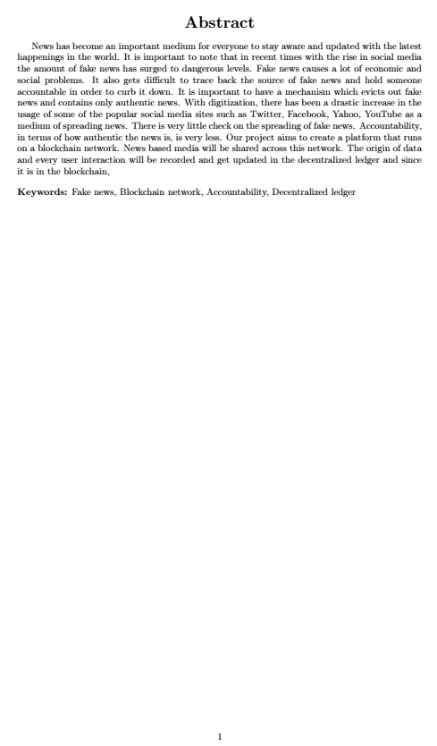

**3. Develop a LaTeX script to create a simple title page of the VTU project Report [Use suitable Logos and text formatting]**

\documentclass[a4paper,10pt]{report}

\usepackage{graphicx}

\usepackage{setspace}

\usepackage{titlesec}

\usepackage{color}

\begin{document}

\begin{titlepage}

\begin{center}

{\LARGE\textbf{Visvesvaraya Technological University}} \\

\vspace{0.3cm}

{\large\textbf{"Jnana Sangama", Belagavi-590018, Karnataka, India}}

\vspace{0.5cm}

\\

\includegraphics[width=0.3\textwidth]{vtu-logo.jpg}

\\

\vspace{0.5cm}

{\large\textbf{A Project Report on}}\\

\vspace{0.5cm}

{\color{red}\LARGE\textbf{Title of the Project}}\\

\vspace{0.5cm}

{\color{green}\large\textbf{Submitted for the award of degree of}}\\

\vspace{0.5cm}

{\color{blue}\large\textbf{Bachelor of Engineering }}\\

\vspace{0.2cm}

{\color{blue}\large\textbf{In }}\\

\vspace{0.2cm}

{\color{blue}\large\textbf{Computer Science \& Engineering }}\\

\vspace{0.5cm}

{\large\textbf{Submitted by}}\\

\vspace{0.5cm}

{\Large\textbf{Your Name (USN: Your USN)}}\\

\vspace{0.5cm}

{\color{red}\large\textbf{Under the guidance of}}\\

\vspace{0.5cm}

{\Large\textbf{Name of Your Guide}}\\

\vspace{0.2cm}

{\large\textbf{Asst.Prof, Department of CS\& E}}\\

\vspace{0.5cm}

\includegraphics[width=0.2\textwidth]{iceas.jpg}

\vspace{0.5cm}\\

{\large\textbf{Department of Computer Science \& Engineering}} \\

\vspace{0.3cm}

{\Large\textbf{Impact College of Engineering \& Applied Sciences}}\\

\vspace{0.3cm}

{\large\textbf{Year}}\\

\end{center}

\end{titlepage}

\end{document}

**OUTPUT -**



**EXPLANATION –**

* \documentclass[a4paper,10pt]{report}: Specifies the document class as report, which is suitable for longer documents with chapters. Options [a4paper,10pt] set the paper size to A4 and the base font size to 10 points.
* \usepackage{graphicx}: Enables inclusion of images with \includegraphics.
* \usepackage{setspace}: Provides commands for setting line spacing \usepackage{titlesec}: Allows customization of section titles.
* \usepackage{color}: Allows the use of colored text with \color.
* \begin{titlepage}: Starts the title page environment. This environment is used to create a custom title page with specific formatting.
* \begin{center}: Centers the following content horizontally within the page.
* {\LARGE\textbf{Visvesvaraya Technological University}} \\: Sets the university name in large size (\LARGE) and bold (\textbf), followed by a line break (\\).
* \vspace{0.3cm}: Adds vertical space of 0.3 cm
* {\large\textbf{"Jnana Sangama", Belagavi-590018, Karnataka, India}}: Sets the location and address in smaller size (\large) and bold (\textbf).
* \includegraphics[width=0.3\textwidth]{vtu-logo.jpg}: Inserts an image (vtu-logo.jpg) with a width of 30% of the text width (0.3\textwidth).
* \\: Starts a new line.
* {\color{red}\LARGE\textbf{Title of the Project}}\\: Sets the title of the project in large size (\LARGE), bold (\textbf), and red color (\color{red}), followed by a line break (\\).
* \includegraphics[width=0.2\textwidth]{iceas.jpg}: Inserts an image (iceas.jpg) with a width of 20% of the text width (0.2\textwidth).

**4. Develop a LaTeX script to create the Certificate Page of the Report [Use suitable commands to leave the blank spaces for user entry]**

\documentclass[a4paper,10pt]{report}

\usepackage{graphicx}

\usepackage{setspace}

\usepackage{titlesec}

\usepackage{ragged2e}

\usepackage{color}

\begin{document}

\begin{titlepage}

\begin{center}

\LARGE \textbf{Impact College Of Engineering \& Applied Sciences} \\

\vspace{0.5cm}

\includegraphics[width=0.2\textwidth]{iceas.jpg}

\vspace{0.5cm}

\Large \textbf{Department of Computer Science \& Engineering} \\

\vspace{0.5cm}

\color{red} \Large \textbf{CERTIFICATE}\par

\end{center}

\vspace{1cm}

\justify {This is to certify that Mr. XYZ bearing USN: 1IC20CS00X is a bonafide student of Bachelor of Engineering course of the Department of Computer Science and Engineering, VTU, Belgavi, affiliated to Visvesvaray Technological University, Belagavi. Project report on "Context-based Diversication of Search Engines" is prepared by him under the guidance of Prof. ABC in partial fulfillment of the requirements for the award of the degree of Bachelor of Engineering of Visvesvaraya Technological University, Belagavi, Karnataka}

\\

\\

\\

\\

\\

............................ \hspace{14mm} .............................\hspace{14mm}.........................

%\newline

%\newline

Signature of Guide \hspace{13mm} Signature of HoD \hspace{12mm} Signature of Principal

\begin{center}

\vspace{2cm}

\textbf{\small EXTERNAL EXAMINER}

\end{center}

\vspace{5mm}

Name of Examiners \hspace{60mm} Signature with date

\newline

\newline 1.

\newline

\newline 2.

\end{titlepage}

\end{document}

**OUTPUT -**



**EXPLANATION –**

* \usepackage{ragged2e} - Provides enhanced commands for justifying text (\justify).
* \justify: Switches the text alignment to justified.
* ............................ \hspace{14mm} .............................\hspace{14mm}.........................: Provides space for signatures of the guide, HoD (Head of Department), and Principal, each spaced 14 mm apart horizontally.
* \textbf{\small EXTERNAL EXAMINER}: Sets "EXTERNAL EXAMINER" in small size (\small) and bold (\textbf).
* Name of Examiners \hspace{60mm} Signature with date: Aligns text "Name of Examiners" 60 mm from the left margin, followed by "Signature with date".
* \newline: Starts a new line.
* 1 and 2.: Lists numbered items 1 and 2.

**5. Develop a LaTeX script to create a document that contains the following table with proper labels.**

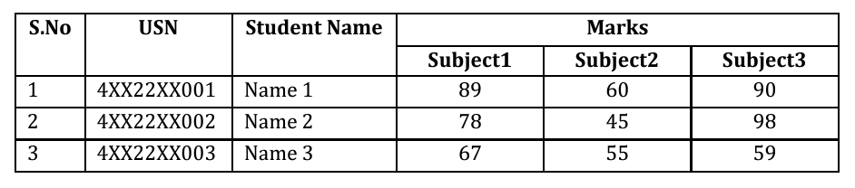

\documentclass[10pt,a4paper]{article}

\usepackage[left=2cm,right=2cm,top=2cm,bottom=2cm]{geometry}

\usepackage{multirow}

\begin{document}

\begin{center}

\begin{Large}

\textbf{Table Demo}

\end{Large}

\end{center}

\section*{Marks Table}

\begin{tabular}{|c|c|c|c|c|c|}

\hline

Sl.No & USN & Student Name & \multicolumn{3}{c|}{Marks}\\

\cline{4-6}

& & & Subject1 & Subject2 & Subject3 \\ \hline

1& 4XX22XX001 & Name1 & 89 & 60 & 90 \\ \hline

2 & 4XX22XX002 & Name2 & 78 & 45 & 98 \\ \hline

3 & 4XX22XX003 & Name3 & 67 & 55 & 59 \\ \hline

\end{tabular}

\end{document}

**OUTPUT -**

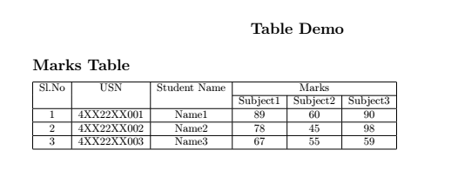

**EXPLANATION –**

When compiled, this code will produce a document with a centered title "Table Demo", a section titled "Marks Table" (without a section number), and a table listing student marks for three subjects.

* \documentclass[10pt,a4paper]{article}
* This line specifies the document class. Here, article is chosen, which is suitable for shorter documents like articles, short reports, or papers.
* 10pt sets the default font size to 10 points.
* a4paper specifies the paper size as A4.
* \usepackage[left=2cm,right=2cm,top=2cm,bottom=2cm]{geometry}
* This line imports the geometry package, which is used to control the layout of the page.
* The left=2cm, right=2cm, top=2cm, and bottom=2cm options set the margins to 2 centimeters on each side.
* \usepackage{multirow}
* This line imports the multirow package, which provides commands to span multiple rows in tables.

\begin{Large}

\textbf{Table Demo}

\end{Large}

* \begin{Large} ... \end{Large} sets the font size to a larger size.
* \textbf{...} makes the text bold.
* \section*{Marks Table}
* This line creates an unnumbered section with the title "Marks Table".
* \section*{...} creates a section without numbering (the asterisk * removes the numbering).

\begin{tabular}{|c|c|c|c|c|c|}

\hline

Sl.No & USN & Student Name & \multicolumn{3}{c|}{Marks}\\

\cline{4-6}

& & & Subject1 & Subject2 & Subject3 \\ \hline

1& 4XX22XX001 & Name1 & 89 & 60 & 90 \\ \hline

2 & 4XX22XX002 & Name2 & 78 & 45 & 98 \\ \hline

3 & 4XX22XX003 & Name3 & 67 & 55 & 59 \\ \hline

\end{tabular}

* These lines create a table using the tabular environment.
* |c|c|c|c|c|c| specifies the alignment and vertical bars for the table columns. Each c indicates that the content in that column should be centered.
* \hline inserts horizontal lines.
* Sl.No & USN & Student Name & \multicolumn{3}{c|}{Marks}\\ creates the header row with "Sl.No", "USN", and "Student Name" in individual columns. \multicolumn{3}{c|}{Marks} spans the next three columns under a single heading "Marks".
* \cline{4-6} draws a horizontal line only across columns 4 to 6, separating the "Marks" header from the subsequent subject columns.
* & & & Subject1 & Subject2 & Subject3 \\ creates the sub-header row for the "Marks" section, with "Subject1", "Subject2", and "Subject3" as the column headings.
* 1& 4XX22XX001 & Name1 & 89 & 60 & 90 \\ represents the first data row with student details and marks for three subjects.
* \hline after each row adds a horizontal line to separate the rows.

**6. Develop a LaTeX script to include the side-by-side graphics/pictures/figures in the document by using the subgraph concept**

\documentclass{standalone}

\usepackage{tikz}

\usetikzlibrary{graphs.standard}

\begin{document}

\begin{tikzpicture}

\graph[nodes={circle,draw},simple]

{

subgraph K_n [n=8,clockwise];

};

\end{tikzpicture}

\begin{tikzpicture}

\graph[nodes={circle,draw},simple]

{

subgraph K_n [n=8, clockwise] -> mid;

};

\end{tikzpicture}

\begin{tikzpicture}

\graph[nodes={circle,draw},simple]

{

subgraph K_n [n=8,clockwise];

};

\end{tikzpicture}

\end{document}

**OUTPUT -**

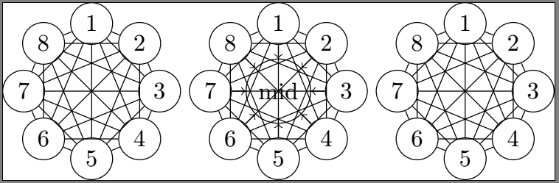

**EXPLANATION –**

This LaTeX code uses the `standalone` document class and TikZ to draw three complete graphs \( K_8 \) (complete graphs with 8 vertices). Each graph is created within its own `tikzpicture` environment, and the nodes are styled as circles with outlines.

* \documentclass{standalone} - This line specifies the document class. Here, `standalone` is used, which is suitable for creating standalone graphics or figures without the need for a complete document setup.
* \usepackage{tikz} ``` - This line imports the `tikz` package, a powerful tool for creating graphics programmatically within LaTeX.
* \usetikzlibrary{graphs.standard} - This line imports the `graphs.standard` library from TikZ, which provides standard graph drawing utilities.
* latex \begin{document} - This line starts the content of the document.
* \begin{tikzpicture} - This line starts a TikZ picture environment, where you can draw graphics. `
* \graph[nodes={circle,draw},simple] { subgraph K_n [n=8,clockwise]; };
* `\graph` is a command from the `graphs.standard` library for creating graphs.
* `nodes={circle,draw}` specifies that the nodes in the graph should be drawn as circles.
* `simple` indicates that the graph should be a simple graph (no multiple edges or loops).
* `subgraph K_n [n=8,clockwise]` specifies a complete graph \( K_n \) with \( n=8 \) vertices arranged in a clockwise manner. A complete graph means every pair of distinct vertices is connected by a unique edge. - The whole block `{...}` within `\graph` defines the structure and properties of the graph.
* \end{tikzpicture} - This line ends the TikZ picture environment.
* `subgraph K_n [n=8, clockwise] -> mid;` creates the same complete graph with 8 vertices arranged clockwise, with a mid node.

**7.Develop a LaTeX script to create a document that consists of the following two mathematical equations**

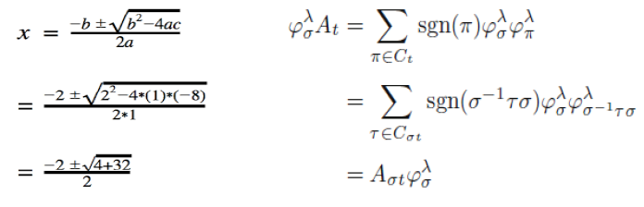

\documentclass[10pt,a4paper]{article}

\usepackage{amsmath,nccmath}

\usepackage[left=2cm,right=2cm,top=2cm,bottom=2cm]{geometry}

\begin{document}

\begin{center}

\Large{\textbf{Equations in \LaTeX}}

\end{center}

\section*{Equation 1}

\begin{fleqn}

\[

x = \frac{-b \pm \sqrt{b^{2}-4ac}}{2a}

\]

\[

= \frac{-2 \pm \sqrt{2^{2}-4*(1)*(-8)}}{2*1}

\]

\[

= \frac{-2 \pm \sqrt{4+32}}{2}

\]

\end{fleqn}

\section*{Equation 2}

\begin{fleqn}

\[

\varphi^{\lambda}_{\sigma}A_{t} = \sum_{\pi \in C_{t}} sgn(\pi)\varphi^{\lambda}_{\sigma}\varphi^{\lambda}_{\pi}

\]

\[

= \sum_{\tau \in C_{\sigma t}} sgn(\sigma^{-1}\tau\sigma)\varphi^{\lambda}_{\sigma}\varphi^{\lambda}_{\sigma^{-1}\tau\sigma}

\]

\[

= A_{\sigma t} \varphi^{\lambda}_{\sigma}

\]

\end{fleqn}

\end{document}

**OUTPUT -** 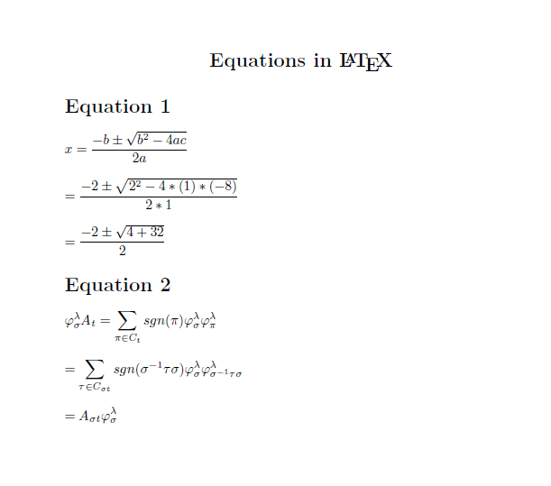

**EXPLANATION –**

This LaTeX code defines an article document with specific formatting options and packages for mathematical typesetting. It includes two sections with mathematical equations displayed in a left-aligned format (fleqn environment). Each equation is presented with step-by-step computations or mathematical expressions.

* \usepackage{amsmath,nccmath} - This line includes the amsmath package, which provides extensive support for mathematical typesetting in LaTeX, and nccmath package, which offers additional math environments and commands.
* amsmath(American Mathematical Society Mathematics) make it easier to write and format complex mathematical expressions, equations.
* nccmath (New Century Schoolbook Math) provides some enhancements to math typesetting, it is generally used in conjunction with other packages like amsmath to leverage a broader range of features and capabilities in LaTeX document preparation.
* \begin{fleqn} - Begins a math environment (fleqn aligns equations to the left) and displays three equations related to solving a quadratic equation. Each equation is enclosed in \[ \], which is LaTeX's way of starting and ending displayed math mode.

**8.Develop a LaTeX script to demonstrate the presentation of Numbered theorems, definitions, corollaries, and lemmas in the document**

\documentclass{article}

\usepackage{amsthm}

\newtheorem{theorem}{Theorem}[section]

\newtheorem{definition}[theorem]{Definition}

\newtheorem{corollary}[theorem]{Corollary}

\newtheorem{lemma}[theorem]{Lemma}

\begin{document}

\section{Theorems}

\begin{theorem}

Let A be the hypotenuse, B be the base, and C be the height of the triangle. According to the Pythagorean theorem, the square of the hypotenuse of a right-angled triangle is equal to the sum of the squares of the sides of the triangle.

\end{theorem}

\section{Definition}

\begin{definition}

Pythagoras theorem states that, in a right triangle, the square of the hypotenuse is equal to the sum of the square of the other two sides.

\end{definition}

\section{Corollary}

\begin{corollary}

if a triangle has side lengths a, b, c, with, then: If \[c^2 > a^2 + b^2\], then the triangle is obtuse. If \[c^2 = a^2 + b^2\], then the triangle is right. If \[c^2 < a^2 + b^2\], then the triangle is acute.

\end{corollary}

\section{Lemma}

\begin{lemma}

Triangles with the same base and height have the same area. A triangle which has the same base and height as a side of a square has the same area as a half of the square.

\end{lemma}

\end{document}

**OUTPUT –**

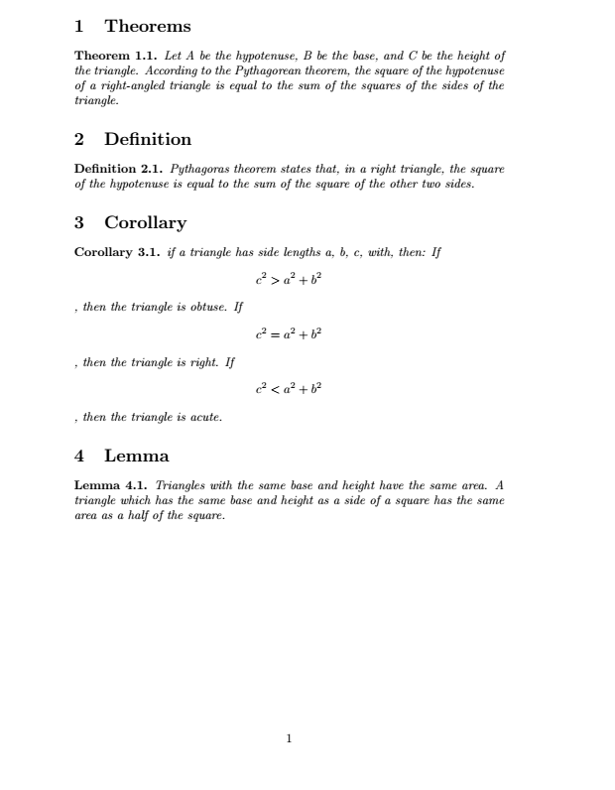

**EXPLANATION –**

* \usepackage{amsthm} - amsthm is used for typesetting mathematical theorems, definitions, lemmas, and corollaries with enhanced formatting and numbering capabilities.
* \newtheorem{theorem}{Theorem}[section]: Defines a theorem environment named theorem which will be numbered within each section. The numbering is tied to the section, so the first theorem in each section will be numbered as "Theorem 1", "Theorem 2", etc.
* \newtheorem{definition}[theorem]{Definition}: Defines a definition environment that shares the numbering with theorem. So, definitions will be numbered consecutively with theorems within each section.
* \newtheorem{corollary}[theorem]{Corollary}: Similar to definition, this defines a corollary environment that shares numbering with theorem.
* \newtheorem{lemma}[theorem]{Lemma}: Defines a lemma environment that shares numbering with theorem.
* \section{Theorems} - Starts a new section titled "Theorems".
* \begin{theorem} \end{theorem} – Begins and ends a theorem environment and states a theorem about the Pythagorean theorem.
* \section{Definition} - Starts a new section titled "Definition".
* \begin{definition\end{definition} - Begins and ends a definition environment and provides a definition of the Pythagorean theorem.
* \section{ Corollary } - Starts a new section titled "Corollary".
* \begin{corollary}\end{corollary} - Begins a corollary environment and states corollaries related to the Pythagorean theorem regarding triangle types based on side lengths.
* \section{Lemma} - Starts a new section titled "Lemma".
* \begin{lemma}\end{lemma}- Begins and ends a lemma environment and states a lemma related to triangles and their areas.

1. **Develop a LaTeX script to create a document that consists of two paragraphs with a minimum of 10 citations in it and display the reference in the section.**

**main.tex**

\documentclass{article}

\usepackage{graphicx}

\begin{document}

\begin{center}

\Large{\textbf{References Demo}}

\end{center}

\section{Introduction}

For disaster management, uncertainty handling is the main key problem. But, in Joint Service deployment and Requests Allocation~(JSR) domain, research work mainly uses the approaches such as deterministic optimization \cite{hardtoshare, multicell, bandwidth}, Lyapunov optimization \cite{dataintensive}, stochastic optimization, replication of services to achieve high reliability, and forecasting of user requests using machine learning without considering uncertainty. In deterministic optimization \cite{edgeuav}, request demand is known before the run. However, in online optimization, time is divided into slots and performs optimization per slot basis, which does not consider uncertain demand. Even if we used any probability distribution to model demand, it does not provide the correct model/pattern to define the uncertain data \cite{edgeuncertainty}. Using a replication approach to achieve high availability also incurs extra resource cost \cite{robust}. Using the forecasting method also, we can not predict the impact of uncertain events on the requests, which may lead to under-provisioning/over-provisioning resources to process the required tasks \cite{rsome}.

\section{Experiment Setup and Performance Parameters}

To demonstrate the efficiency of the proposed approaches, we will simulate the scenario for an urban site affected by any natural calamity \cite{oilindustry}. To implement optimization models, we will use the IBM Cplex Optimizer tool \cite{cplex}.

\bibliographystyle{IEEEtran}

\bibliography{ref}

\end{document}

**ref.bib**

@ARTICLE{oilindustry,

author={Ngoenriang, Napat and Turner, Stephen John and Niyato, Dusit and Supittayapornpong, Sucha}, journal={IEEE Internet of Things Journal},

title={Joint UAV-Placement and Data Delivery in Aerial Inspection under Uncertainties}, year={2021}, volume={}, number={}, pages={1-1},

doi={10.1109/JIOT.2021.3113713}}

@ARTICLE{uavservice,

author={Qu, Yuben and Dai, Haipeng and Wang, Haichao and Dong, Chao and Wu, Fan and Guo, Song and Wu, Qihui}, journal={IEEE Journal on Selected Areas in Communications}, title={Service Provisioning for UAV-Enabled Mobile Edge Computing}, year={2021}, volume={39}, number={11},

pages={3287-3305}, doi={10.1109/JSAC.2021.3088660}

}

@misc{cplex,

author = {IBM}, title = {IBM CPLEX Optimizer},

howpublished = "\url{https://www.ibm.com/in-en/analytics/cplex-optimizer}",

year = {2021}, note = "[Online; accessed 3-Feb-2022]"

}

@misc{rsome,

author = {NSU}, title = {RSOME}, howpublished = "\url{https://xiongpengnus.github.io/rsome/}",

year = {2021}, note = "[Online; accessed 3-Feb-2022]"

}

@INPROCEEDINGS{hardtoshare,

author={He, Ting and Khamfroush, Hana and Wang, Shiqiang and La Porta, Tom and Stein, Sebastian}, booktitle={IEEE 38th International Conference on Distributed Computing Systems (ICDCS)}, title={It's Hard to Share: Joint Service Placement and Request Scheduling in Edge Clouds with Sharable and Non-Sharable Resources}, year={2018}, volume={}, number={}, pages={365-375}, doi={10.1109/ICDCS.2018.00044}

}

@INPROCEEDINGS{multicell,

author={Poularakis, Konstantinos and Llorca, Jaime and Tulino, Antonia M. and Taylor, Ian and Tassiulas, Leandros}, booktitle={IEEE Conference on Computer Communications (INFOCOM)}, title={Joint Service Placement and Request Routing in Multi-cell Mobile Edge Computing Networks}, year={2019}, volume={}, number={}, pages={10-18}, doi={10.1109/INFOCOM.2019.8737385}

}

@ARTICLE{bandwidth,

author={Poularakis, Konstantinos and Llorca, Jaime and Tulino, Antonia M. and Taylor, Ian}, journal={IEEE/ACM Transactions on Networking}, title={Service Placement and Request Routing in MEC Networks With Storage, Computation, and Communication Constraints}, year={2020}, volume={28}, number={3}, pages={1047-1060}, doi={10.1109/TNET.2020.2980175}

}

@INPROCEEDINGS{dataintensive,

author={Farhadi, Vajiheh and Mehmeti, Fidan and He, Ting and Porta, Tom La and Khamfroush, Hana and Wang, Shiqiang and Chan, Kevin S},

booktitle={IEEE Conference on Computer Communications(INFOCOM)}, title={Service Placement and Request Scheduling for Data-intensive Applications in Edge Clouds}, year={2019}, volume={}, number={}, pages={1279-1287}, doi={10.1109/INFOCOM.2019.8737368}

}

@ARTICLE{resource,

author={Ahmed, Shakil and Chowdhury, Mostafa Zaman and Sabuj, Saifur Rahman and Alam, Md Imtiajul and Jang, Yeong Min}, journal={IEEE Access}, title={Energy-Efficient UAV Relaying Robust Resource Allocation in Uncertain Adversarial Networks}, year={2021}, volume={9}, number={}, pages={59920-59934}, doi={10.1109/ACCESS.2021.3073015}}

@ARTICLE{resource2, author={Yang, Zhaohui and Pan, Cunhua and Wang, Kezhi and Shikh-Bahaei, Mohammad}, journal={IEEE Transactions on Wireless Communications}, title={Energy Efficient Resource Allocation in UAV-Enabled Mobile Edge Computing Networks}, year={2019}, volume={18}, number={9}, pages={4576-4589}, doi={10.1109/TWC.2019.2927313}}

@ARTICLE{offload, author={Apostolopoulos, Pavlos Athanasios and Fragkos, Georgios and Tsiropoulou, Eirini Eleni and Papavassiliou, Symeon}, journal={IEEE Transactions on Mobile Computing}, title={Data Offloading in UAV-assisted Multi-access Edge Computing Systems under Resource Uncertainty}, year={2021}, volume={}, number={}, pages={1-1}, doi={10.1109/TMC.2021.3069911}}

@INPROCEEDINGS{offload2, author={Zhou, Fuhui and Wu, Yongpeng and Sun, Haijian and Chu, Zheng}, booktitle={2018 IEEE International Conference on Communications (ICC)}, title={UAV-Enabled Mobile Edge Computing: Offloading Optimization and Trajectory Design}, year={2018}, volume={}, number={}, pages={1-6}, doi={10.1109/ICC.2018.8422277}}

@ARTICLE{trajectory, author={Wang, Kai and Zhang, Xiao and Duan, Lingjie and Tie, Jun}, journal={IEEE Transactions on Mobile Computing}, title={Multi-UAV Cooperative Trajectory for Servicing Dynamic Demands and Charging Battery}, year={2021}, volume={}, number={}, pages={1-1}, doi={10.1109/TMC.2021.3110299}}

@article{edgeuncertainty,

author = {Xu, Xiaolong and Cao, Hao and Geng, Qingfan and Liu, Xihua and Dai, Fei and Wang, Chuanjian}, title = {Dynamic resource provisioning for workflow scheduling under uncertainty in edge computing environment}, journal = {Concurrency and Computation: Practice and Experience}, volume = {n/a}, number = {n/a}, pages = {e5674}, keywords = {edge computing, SDN, uncertainty, workflow scheduling}, doi = {https://doi.org/10.1002/cpe.5674}

}

@ARTICLE{edgeuav, author={Qu, Yuben and Dai, Haipeng and Wang, Haichao and Dong, Chao and Wu, Fan and Guo, Song and Wu, Qihui}, journal={IEEE Journal on Selected Areas in Communications}, title={Service Provisioning for UAV-Enabled Mobile Edge Computing}, year={2021}, volume={39}, number={11}, pages={3287-3305}, doi={10.1109/JSAC.2021.3088660}}

@inproceedings{mobility,

title={UAV 3D Mobility Model Oriented to Dynamic and Uncertain Environment}, author={Na Wang and Nan Di and Fei Dai and Fangxin Liu},

booktitle={ICA3PP}, year={2018}

}

@ARTICLE{robust, author={Li, Bo and He, Qiang and Cui, Guangming and Xia, Xiaoyu and Chen, Feifei and Jin, Hai and Yang, Yun}, journal={IEEE Transactions on Services Computing}, title={READ: Robustness-oriented Edge Application Deployment in Edge Computing Environment}, year={2020}, volume={}, number={}, pages={1-1}, doi={10.1109/TSC.2020.3015316}}

**STEPS TO EXECUTE -**

* Save first part in main.tex
* Second part in ref.bib
* Open main.tex
* Run PDFLatex
* Run BibTex
* Run PDFLatex
* In the last, Run Quick Build

**OUTPUT –**

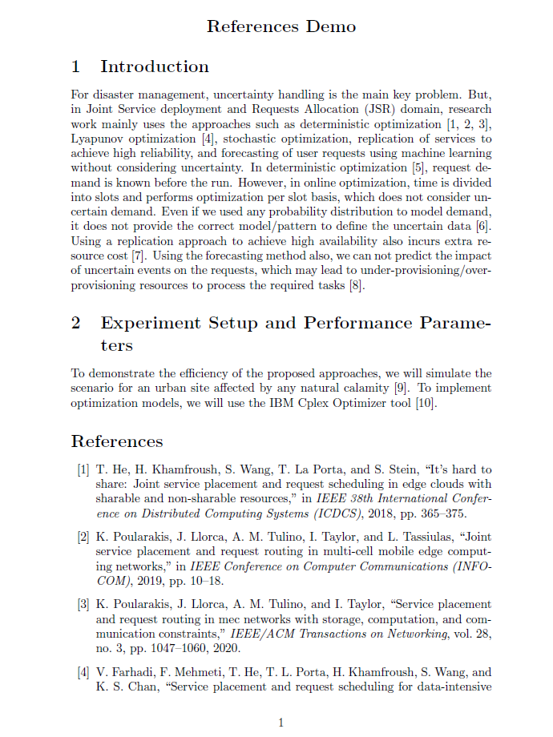

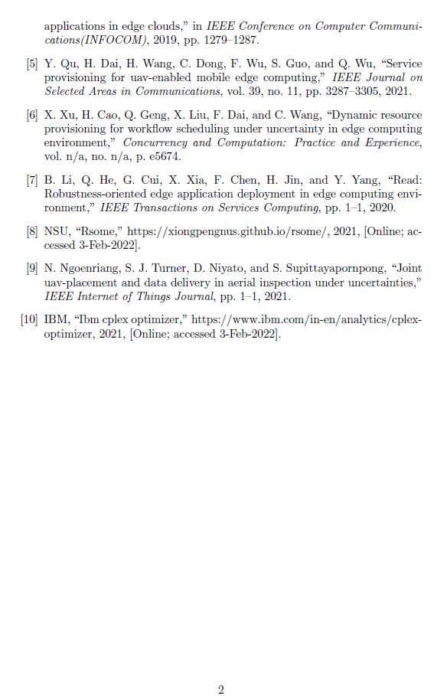

**EXPLANATION –**

This LaTeX document template demonstrates the structure commonly used for academic papers. It includes sections for introduction, experimental setup, and references. Citations are managed through BibTeX, and the document is formatted according to the IEEEtran bibliography style.

* \cite{} - is a command used to insert citations into a document.

When you use \cite{key} in your LaTeX document, LaTeX looks up the key in your bibliography database (ref.bib in this case) to retrieve the corresponding citation information.

LaTeX then formats the citation in the document according to the specified bibliography style (IEEEtran)

* \bibliographystyle{IEEEtran}
* This command sets the bibliography style to IEEEtran. The bibliography style determines how citations and references are formatted in the document.
* IEEEtran is a popular bibliography style provided by the IEEE (Institute of Electrical and Electronics Engineers). It formats references typically used in engineering, computer science, and other technical fields.
* The style governs how citations are numbered or labeled in the text and how the corresponding entries are formatted in the bibliography section.
* \bibliography{ref} - This command specifies the bibliography database file (ref.bib in this case) that contains all the bibliographic entries referenced in the document.
* **@ARTICLE{oilindustry,  
  author={Ngoenriang, Napat and Turner, Stephen John and Niyato, Dusit and Supittayapornpong, Sucha}, journal={IEEE Internet of Things Journal}, title={Joint UAV-Placement and Data Delivery in Aerial Inspection under Uncertainties}, year={2021}, volume={}, number={}, pages={1-1}, doi={10.1109/JIOT.2021.3113713}}**

@ARTICLE{oilindustry, ... }: This indicates that you are citing an article in a BibTeX format. oilindustry is the citation key, which you can use to reference this work in your LaTeX document.

author={Ngoenriang, Napat and Turner, Stephen John and Niyato, Dusit and Supittayapornpong, Sucha}: These are the authors of the article. In this case, the authors are Napat Ngoenriang, Stephen John Turner, Dusit Niyato, and Sucha Supittayapornpong.

journal={IEEE Internet of Things Journal}: This specifies the journal in which the article was published, which is the "IEEE Internet of Things Journal".

title={Joint UAV-Placement and Data Delivery in Aerial Inspection under Uncertainties}: This is the title of the article.

year={2021}: The year of publication of the article.

volume={}, number={}, pages={1-1}: This typically includes information such as volume, issue number, and page numbers of the article. In this case, the volume, number, and specific pages are not provided (denoted by {}), and only the page range is specified as "1-1", indicating it's a single-page article.

doi={10.1109/JIOT.2021.3113713}: The Digital Object Identifier (DOI) for the article, which provides a persistent link to its location on the internet.

* **@inproceedings{mobility,**

**title={UAV 3D Mobility Model Oriented to Dynamic and Uncertain Environment}, author={Na Wang and Nan Di and Fei Dai and Fangxin Liu},**

**booktitle={ICA3PP}, year={2018}**

**}**

@inproceedings{mobility, ... }: This indicates that you are citing a paper presented at a conference (inproceedings) and mobility is the citation key, which can be used to reference this work in your LaTeX document.

title={UAV 3D Mobility Model Oriented to Dynamic and Uncertain Environment}: This is the title of the paper.

author={Na Wang and Nan Di and Fei Dai and Fangxin Liu}: These are the authors of the paper. In this case, the authors are Na Wang, Nan Di, Fei Dai, and Fangxin Liu.

booktitle={ICA3PP}: This specifies the name of the conference where the paper was presented. In this case, the conference is abbreviated as "ICA3PP".

year={2018}: The year of the conference presentation (and presumably the publication of the proceedings).

* **@misc{cplex, author = {IBM}, title = {IBM CPLEX Optimizer}, howpublished = "\url{https://www.ibm.com/in-en/analytics/cplex-optimizer}", year = {2021}, note = "[Online; accessed 3-Feb-2022]" }**

@misc{cplex, ... }: This indicates that you are citing a miscellaneous item that doesn't fit into any other standard category like article or book. cplex is the citation key, which can be used to reference this work in your LaTeX document.

author = {IBM}: This specifies the author or the entity responsible for the item. In this case, the author is IBM.

title = {IBM CPLEX Optimizer}: This is the title of the item being cited, which is "IBM CPLEX Optimizer".

howpublished = "\url{https://www.ibm.com/in-en/analytics/cplex-optimizer}": This field specifies how the item is published or accessed. Here, it uses the \url{} command to format a URL link to the webpage where the IBM CPLEX Optimizer information can be found.

year = {2021}: The year when the item was published or last updated, which is 2021 in this case.

note = "[Online; accessed 3-Feb-2022]": Additional information about the item, such as access details. It indicates that the item is available online and was accessed on February 3, 2022.

**10 . Develop a LaTeX script to design a simple tree diagram or hierarchical structure in the document with appropriate labels using the Tikz library**

\documentclass{standalone}

\usepackage{tikz}

\usetikzlibrary{graphs.standard}

\begin{document}

\begin{tikzpicture}

[level distance=10mm,

every node/.style={fill=blue!40,circle,inner sep=1pt},

level 1/.style={sibling distance=20mm,nodes={fill=blue!40}},

level 2/.style={sibling distance=10mm,nodes={fill=blue!40}},

level 3/.style={sibling distance=5mm,nodes={fill=blue!40}}]

\node {50}

child {node {40}

child {node {10}}

child {node {12}}

}

child {node {60}

child {node {19}

child {node {11}}

}

child {node {18}}

};

\end{tikzpicture}

\end{document}

**OUTPUT –**

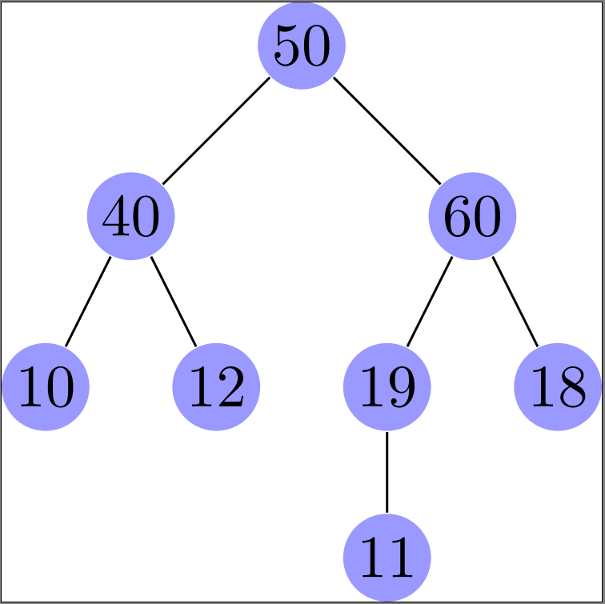

**EXPLANATION –**

* **[level distance=10mm,**: This sets the vertical distance between levels of the tree to 10mm.
* **every node/.style={fill=blue!40,circle,inner sep=1pt},**: This style applies to every node in the tree.
* fill=blue!40: Nodes are filled with a light blue color (blue!40 in the LaTeX color scheme).
* circle: Nodes are circular in shape.
* inner sep=1pt: Sets the inner separation of text from the node border to 1 point.
* **level 1/.style={sibling distance=20mm,nodes={fill=blue!40}},**: Defines the style for nodes at level 1 (direct children of the root).
* sibling distance=20mm: Specifies the horizontal distance between sibling nodes at level 1 as 20mm.
* nodes={fill=blue!40}: Nodes at this level are filled with the same light blue color as defined earlier.
* level 2/.style={sibling distance=10mm,nodes={fill=blue!40}},: Defines the style for nodes at level 2.
* level 3/.style={sibling distance=5mm,nodes={fill=blue!40}}]: Defines the style for nodes at level 3.
* **\node {50}**: This starts the tree structure with a node containing the value 50.
* \node: Begins the definition of a node in TikZ.
* {50}: The content of the node is 50.
* **child {node {40}**: This defines a child node with the value 40 under the root node 50.
* **child {node {10}}**: This defines a child node with the value 10 under the node 40.
* Similarly, child {node {12}} creates another child node with the value 12 under the node 40.
* **child {node {60}**: This defines another child node with the value 60 under the root node 50, alongside the subtree starting from {node {40}.
* {node {60}}: Creates a node with the content 60.
* **child {node {19}**: This defines a child node with the value 19 under the node 60.
* {node {11}}: Creates a child node with the value 11 under the node 19.
* **child {node {18}}**: This creates another child node with the value 18 under the node 60.

**11 Develop a LaTeX script to present an algorithm in the document using algorithm/algorithmic/algorithm2e Library**

\documentclass{article}

\usepackage{algorithm}

\usepackage{algpseudocode}

\begin{document}

\begin{algorithm}

\caption{Euclid's Algorithm}

\begin{algorithmic}[1]

\Procedure{Euclid}{$a,b$}\Comment{The gcd of $a$ and $b$}

\State $r \gets a \bmod b$

\While{$r \neq 0$}\Comment{We have the answer if $r$ is 0}

\State $a \gets b$

\State $b \gets r$

\State $r \gets a \bmod b$

\EndWhile

\State \textbf{return} $b$\Comment{The gcd is $b$}

\EndProcedure

\end{algorithmic}

\end{algorithm}

\end{document}

**OUTPUT –**

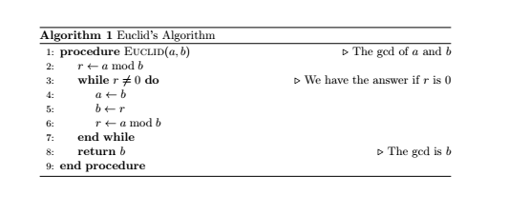

**EXPLANATION –**



**10 = 1,2,5,10 15 = 1,3,5,15**

**a = 10**

**b = 15**

**r = a%b = 10%15=10**

**10!=0**

**a = 15**

**b = 10**

**r = 15%10 = 5**

**5!=0**

**a = 10**

**b = 5**

**r =10%5 = 0**

**return b (5)**

* \usepackage{algorithm}: loads the algorithm package in your LaTeX document. It package provides an environment to write algorithms in a structured way.
* \usepackage{algpseudocode} - provides a set of predefined commands for writing pseudocode algorithms. We can use commands like \State, \If, \Else, \While, \For, etc., to write pseudocode.
* \caption{Euclid's Algorithm}: generates a caption for a figure or table
* \begin{algorithmic}[1]: Begins the algorithmic environment for typesetting algorithms in LaTeX. [1] specifies that line numbering will start from 1 and proceed sequentially unless specified otherwise.
* \Procedure{Euclid}{$a,b$}: Defines a procedure named Euclid that takes two parameters, a and b.
* \Comment{The gcd of $a$ and $b$}: Provides a comment describing the purpose of the procedure, which is to compute the greatest common divisor (gcd) of a and b.
* \State $r \gets a \bmod b$: Assigns the result of a mod b to the variable r. \State is used to denote a statement or step in the algorithm.
* \While{$r \neq 0$}: Begins a while loop that continues as long as r is not equal to 0.
* \Comment{We have the answer if $r$ is 0}: Provides a comment indicating that the gcd is found when r becomes 0.
* \State $a \gets b$: Updates the value of a to b.
* \State $b \gets r$: Updates the value of b to r.
* \State $r \gets a \bmod b$: Recalculates r as a mod b, preparing for the next iteration of the while loop.
* \EndWhile:

Ends the while loop.

* \State \textbf{return} $b$: Returns the value of b, which represents the gcd of the initial values a and b.
* \EndProcedure: Ends the Euclid procedure definition.
* \end{algorithmic}: Ends the algorithmic environment.

**12 Develop a LaTeX script to create a simple report and article by using suitable commands and formats of user choice.**

\documentclass{report}

\usepackage{lipsum}

\title{Sample Report}

\author{John Doe}

\date{\today}

\begin{document}

\maketitle

\tableofcontents

\chapter{Introduction}

\section{Background}

\lipsum[1-2]

\chapter{Methodology}

\section{Data Collection}

\lipsum[3-4]

\chapter{Results}

\section{Analysis}

\lipsum[5-6]

\chapter{Conclusion}

\section{Summary}

\lipsum[7-8]

\end{document}

NOTE – RUN QUICKBUILD TWICE TO GET TABLE OF CONTENTS GENERATED.

**OUTPUT –**



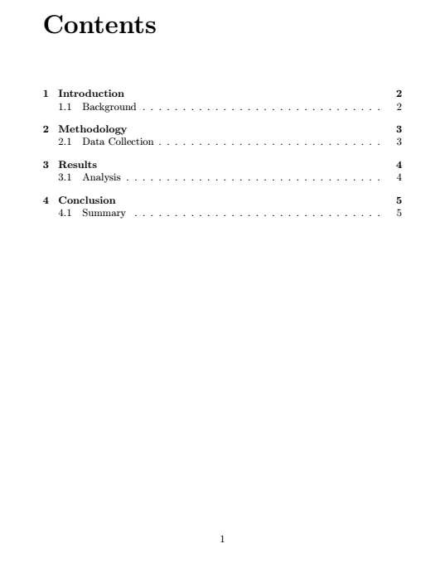

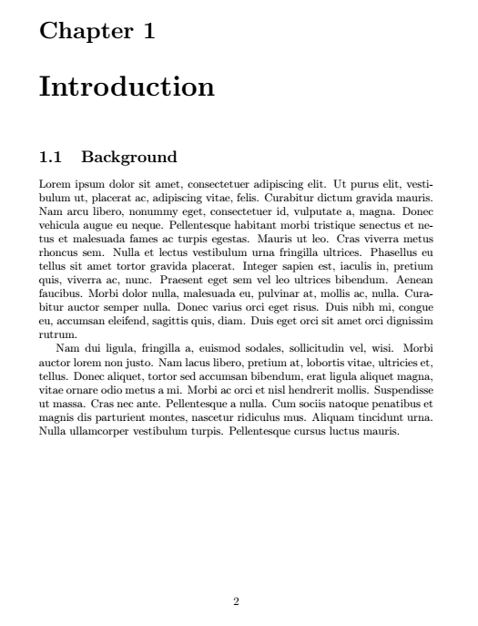

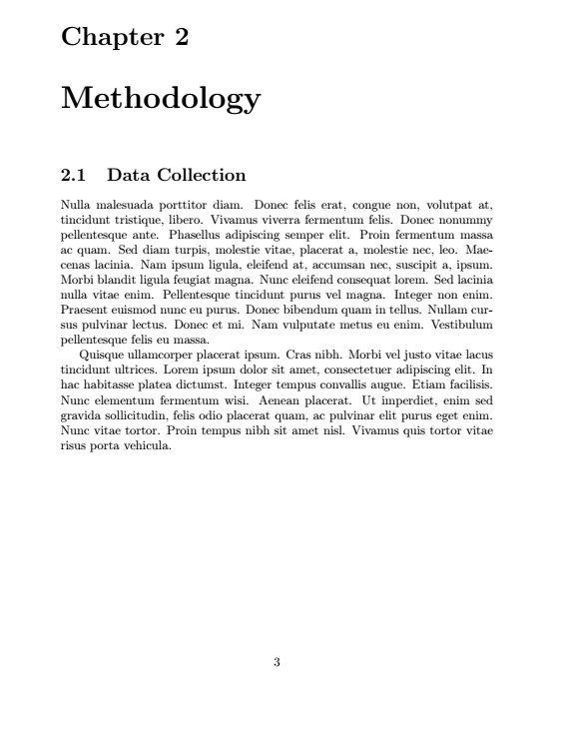

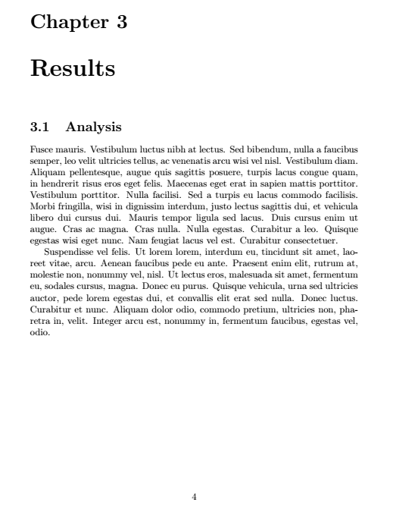

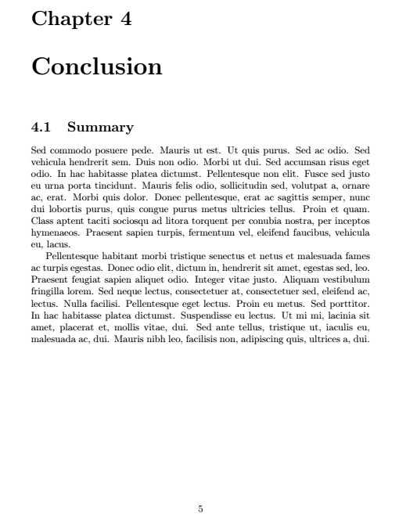

**EXPLANATION –**

* \title{Sample Report} - Defines the title of the report.
* \author{John Doe} - Defines the author of the report.
* \date{\today} - Defines the date of the report.
* \maketitle - Generates the title page using \maketitle, which includes the title, author, and date information as specified.
* \tableofcontents - Generates the table of contents based on the chapters and sections defined in the document.
* \chapter{Introduction}
* \section{Background}
* \lipsum[1-2]

Starts a new chapter titled "Introduction" with a section titled "Background". The \lipsum[1-2] command generates two paragraphs of Lorem Ipsum text for placeholder content.

* \chapter{Methodology}
* \section{Data Collection}
* \lipsum[3-4]

Starts a new chapter titled "Methodology" with a section titled "Data Collection". \lipsum[3-4] generates two paragraphs of Lorem Ipsum text.

* \chapter{Results}
* \section{Analysis}
* \lipsum[5-6]

Starts a new chapter titled "Results" with a section titled "Analysis". \lipsum[5-6] generates two paragraphs of Lorem Ipsum text.

* \chapter{Conclusion}
* \section{Summary}
* \lipsum[7-8]

Starts a new chapter titled "Conclusion" with a section titled "Summary".

* \lipsum[7-8] generates two paragraphs of Lorem Ipsum text.

**SAMPLE VIVA QUESTIONS**

1.What does the command \documentclass{article} do in LaTeX?

2. What is the purpose of the command \usepackage{graphicx} in LaTeX?

3. What does the command \textbf{ } do in LaTeX?

4. What is the purpose of the command \tableofcontents in LaTeX?

5. What does the command \begin{center} do in LaTeX?

6. What is the purpose of the command \maketitle in LaTeX?

7.What is the purpose of the command \pagestyle{ } in LaTeX?

8.What does the command \section{ } do in LaTeX?

9.What does the command \cite{ } do in LaTeX?

10.What is the purpose of the command \caption{ } in LaTeX?

11.What is the purpose of the command \subsection{ } in LaTeX?

12.What is the purpose of the command \begin{tabular} in LaTeX?

13 What is LaTeX?

14 How does LaTeX differ from a word processor like Microsoft Word?

15 Explain the concept of markup language and typesetting.

16 Describe the basic structure of a LaTeX document.

17 What are the components of a LaTeX document preamble?

18 How do you start a new section or chapter in LaTeX?

19 How do you change the font style and size in LaTeX?

20 How do you insert figures and graphics into a LaTeX document?

21 Explain how to manage citations and bibliographies in LaTeX.

22 What is \usepackage{fancyhdr}

23 What is \usepackage{lipsum}

24 What is \pagestyle{fancy}

25 What is \fancyhf{}

26 What is \chead

27 What is \cfoot

28 What is \documentclass[12pt]{article}

29 What is \begin{abstract}

30 What is \usepackage{setspace}?

31 What is \usepackage{titlesec}?

32 What is \usepackage{color}?

33 What are LARGE Large large?

34 What is \textbf?

35 What are \vspace \hspace \center?

36 What are \includegraphics

and \textwidth

37 What is ragged2e?

38 What is \justify ?

39 What is the use of \\

40 What are \usepackage{geometry} and \usepackage{multirow}

41 What are \begin{tabular} and multicolumn?

42 What is the use of & in tabular?

43 Explain standalone, tikz and graphs.standard

44 Explain tikzpicture

45 Explain \usepackage{amsmath,nccmath}

46 What is fleqn?

47 Explain \usepackage{amsthm}, \newtheorem{theorem} and

\newtheorem{definition}

48 Explain \bibliographystyle{IEEEtran} and \bibliography{ref}

49 Explain \label

50 What are \title \author \date